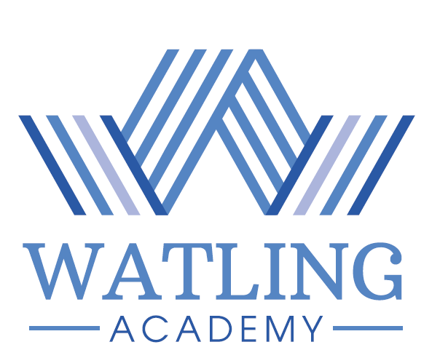

CONSENT TO WATLING ACADEMY’S POLICIES & AGREEMENTS
This section must be signed by both a Parent/Carer and the child named below. (Note: Parents/Carers and students must read the enclosed New Entrant Information Booklet before completing this table).

I/we confirm that I/we have read, understood and agree to the following Watling Academy Policies, Agreements and Consents and to any obligations or actions contained therein: | Please tick to indicate consent/agreement
Attendance Policy
Behaviour Policy
Governors’ Charging Policy
Homework Guidelines
Privacy Notice
Home-School Agreement
Acceptable Use of ICT Agreement
Consent to the administration of paracetamol
Consent to the use of images & video (for in School, on School website, School social media and in the media)
Consent to participate in off-site sports activities (including staff authorisation of emergency medical treatment)

Student Name ______________________________________________

Student Signature ___________________________________________

Parent/Carers Signature ______________________________________

Date ____________________

